Intro to Programming (Python)

Assignment 01

# Overview

In this activity, you learn about creating and using a Python script.

This assignment includes the following tasks:

1. Watch the module videos.
2. Read a book chapter.
3. Review some web pages.
4. Watch additional videos.
5. Apply your knowledge.
6. Document your knowledge.
7. Submit your work.

**Tip:** Consider the following questions while you work through the module to help you focus:

* How do you install python?
* How is python used?
* What are some differences between python and operating system shell scripting?
* How do you run a python script from your desktop?
* How do you run a python script from a command shell?
* What is a console application?
* What is a python script?
* How do you know if python is working?
* Does the python code look different on different operating systems?

# Assignment Steps

The following assignment steps ask you to read about, perform, and write about programming.

***Note:*** *Course assignments help you learn through* ***reading****,* ***watching*** *demonstrations,* ***performing*** *programming in Python, and reflecting on what you learned through* ***writing****. You are strongly encouraged to continue your learning by experimentation.*

## Step 1 - Watch my Video Lecture

Please watch my course lecture for this module. You can find this module lecture(s) here: <https://youtube.com/playlist?list=PLfycUyp06LG9fZllIqBrxLcNV4CR50HEX>

## Step 2 - Read a book chapter

Please **read chapter one** in your textbook. You **do not have to perform the exercises or type in the code**, but it is best if you open the script files as you read about them. You can find the downloadable **book files** **on Canvas** for your convenience.

## Step 3 - Review the following web pages

Please review the following web pages:

1. <https://www.computerhope.com/jargon/c/commandi.htm> (Windows) (external site)
2. <https://www.davidbaumgold.com/tutorials/command-line/> (Mac)
3. <https://www.w3schools.com/python/python_getstarted.asp>

## Step 4 - Additional Videos

There are lots of free videos on the internet, and sometimes it helps to see how other people explain the same topic. So, please watch these:

1. Using Python interactively <https://realpython.com/lessons/running-python-code-interactively/>(external site)
2. Print and Input <https://youtu.be/FhoASwgvZHk> (external site)
3. Python Tutorial for Beginners 1: Install and Setup for Mac and Windows <https://www.youtube.com/watch?v=YYXdXT2l-Gg&vl=en> (external site)
4. Introduction to Batch files <https://youtu.be/kboexp3QiUg> (Windows) (external site)
5. Introduction to Bash files <https://youtu.be/nZqi3BqqeqI> (Mac) (external site)

## Step 5 - Apply your knowledge

Now that you have reviewed the websites and videos, I want you to do some programming with the Python language.

### Step 5.1 Create a Python Script

Create a python script file that allows a user to input their first and last name, then display it back to them as their full name.

**Note:** Mac comes with Python 2 already installed, but please install and use version 3.x for this course.

### Step 5.2 Save your script to a folder

**Create a folder** on your computer **called _PythonClass**. Please use the **C: Drive** on a Windows OS **or** the **Documents** folder on a Mac OS (using the Desktop on either OS is not recommend).

Inside this folder **create** **another folder called Assignment01** and save your script file into this subfolder **as** **test.py (Figures 1 and 2)**.

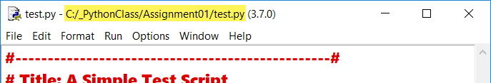

Figure 1: Idle showing the file saved in the correct folder on Windows OS

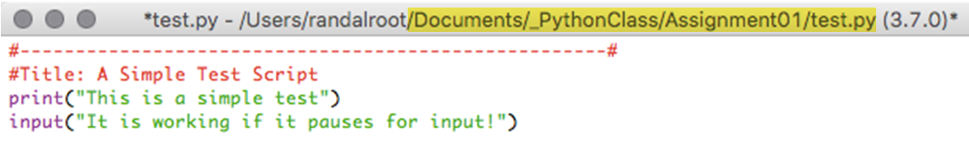

Figure 2: Idle showing the file saved in the correct folder on Mac OS

### Step 5.3 Run Your Script

With the script created and saved in the proper location, run the script in an OS command/shell window, and then capture an image of it working on your computer (Figure 3).

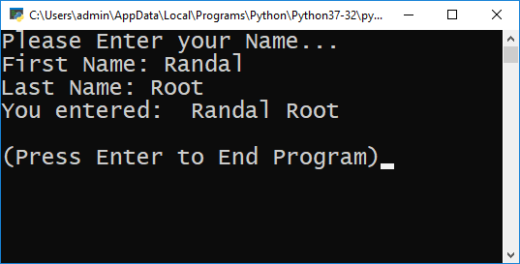

Figure 3: An example of the script running from a command shell.

## Step 6 - Document your knowledge

After you have created and tested your Python script, create a document describing the steps you took in performing this assignment.

**Notes:**

* All resources for this assignment are found in the lectures, recommended reading, or recordings specified in the class syllabus. You do not need to locate additional resources outside of these.
* Your document **must look professional** to get full points! Use my example template and video, in the General Files and Topics module, as a guide for what I expect a professional paper to look like. Make sure you format it like a college paper instead of a text message. Things like your **name, date, class, citations, introductory and summary paragraphs** are always expected! So, not putting these in the document will cost you! ([*See this video for help*](https://youtu.be/9ojhSW9ljjo)!)
* Please **save** your files as a PDF file called **Assignment01_YourNameHere.pdf.** Here is an example from Google Docs, but it is similar in most text editors!

**Important**: Make sure to include an introduction and summary, as well as a heading. It does not have to be perfect, but you won't get credit for it if you turn in a simple blob of text! watch this video to help you understand what I am looking for: [Creating Professional Documents](https://youtu.be/9ojhSW9ljjo)

## Step 7 - Submit your work

Now place your document with the Python script in the Assignment01 folder, then Zip this folder into a “.zip” file, before finally uploading the file to the class assignment page on Canvas.

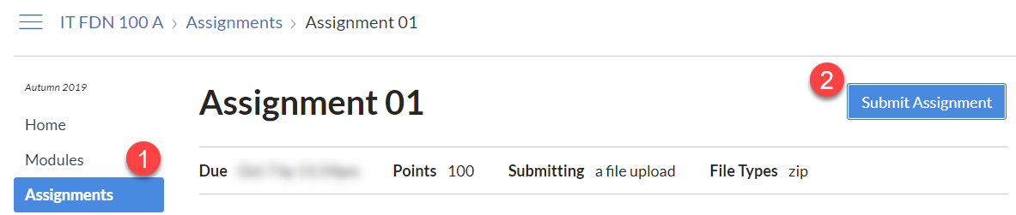

Congratulations! You're done!